There's a KARMIC sweep happening as Saturn moves into Pisces Giving you knowledge on what you want to change. Make two lists. Things you want to resolve or eliminate....and what you want to create. Stay grounded and work from your core reality.
Watch for feelings of time-collapse....as the evolutionary burn happens. [don't get caught up in other people's illusions]. We are all burning off the Karma.-
Yes we're all dancing in the dark.
There have been times I'm ready to pitch everything.
Too many push/pull WTF moments.
Feeling the evolutionary burn... and then
Refusing to get sucked into the collective miasma
Nor let it take me down.
That being said I know what I want and
How I want to do it.
I'm writing.
I'm creating.
I'm revamping.
I'm designing.
I'm seeing clients that were wobbling... righting themselves
With clarity and focus.
When you activate the Leader within there's a push\pull energy to stay the course, stay the same.
It's a time where our emotions and boundaries are being activated personally and collectively, who's pushing who? Maybe like me you're paying attention and tending to...
- What part of me is in fight or flight?
- What do I need to know about emotional security that has left me dancing with my smallness?
- What emotions need tending

"I am the One who is _____________."
First thought, best thought.
:: There are three asks of Aries ::
Lead. Follow. Get out of the Way.
Since March 21st at the first Aries New Moon I've noticed the emotional energy has been up and down. Aries is ruled by Mars... Mars is fiery and hot. His shadow is like a petulant angry teenager- don’t tell me what to do!
Mars gets his marching orders from Venus. Most of our economy runs on Mars energy disconnected from Venus.
"Build it fast. Take out the money. Let it collapse. Rebuild."

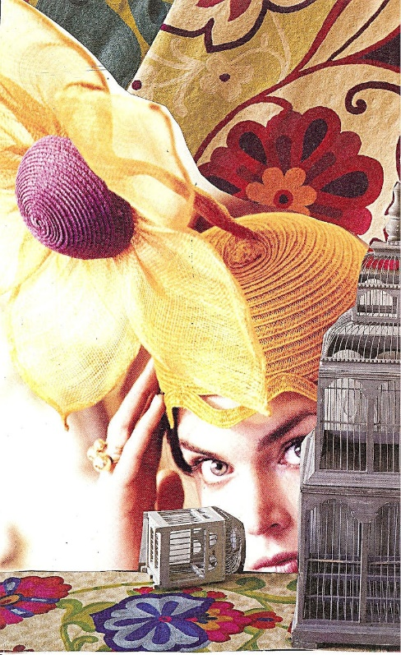
Venus within you wants deeper connections; she is a gatekeeper to source- the god\goddess of your understanding, aligned she brings through grounded wisdom with a fresh approach.
Venus informs Mars- go here, create that- take informed action. Venus connects you to your joy and dreams. When her energy is corrupted or abandoned or negated your ability to dream and create slogs to a halt.
Her absence is felt in the leaders who say we can't do anything about guns, violence, climate change. All this "no can do" is running from the collective 3rd chakra energy. Their time is running out and they know it.
YOU have the capacity to make a difference even in the chaos of the moment. Find what gives you joy in your life and business. Activate that potential. Live your bigness. Love one another. Talk with Venus within you.
New Moons represent new beginnings. Setting a clear intention. Asking questions.
The Sun moving through Aries highlights your issues with courage-leadership, strength, vigilance, boldness. Stand up, put your bonnet on, come out of hiding and shine for all the world to see.
Step 1) In what ways am I vested in a person or process? Whose energy is holding me hostage? When did you stop dancing, laughing, creating? Do a bit of journaling.
Step 2) Where am I hiding my gifts from the world? Hiding behind another so you don’t have to take the LEAD. Caged.
Step 3) Where did I lose power in that relationship-personal + business- and how is that affecting me today?***see below***
This Aries energy- two New Moons + Solar Eclipse- may reveal deep emotions- soul loss attached to you own inner drama|trauma. New Moons bring up our shadow issues- this one around power- and it's activated from March 21 through May 19th when we greet the New Moon in Taurus. Watch what’s triggering you.
The ask is to stay clear of the miasma of the collective.

